Feature-based visual tracking of agricultural implements

Trevor P. Stanhope*. Viacheslav I. Adamchuk**

*McGill University, Montreal, QC (e-mail: trevor.stanhope@mail.mcgill.ca).
**McGill University, Montreal, QC (Tel: 514-398-7657; e-mail: viacheslav.adamchuk@mcgill.ca)
Abstract: Systems which utilize implement-mounted cameras for machinery feedback, e.g. on row crop cultivators and seeders, can be upgraded to provide high-precision ground speed and tracking feedback. This process, known as visual tracking, may be used to compensate for implement dynamics and provide additional feedback in complement with RTK-GNSS receivers and fifth-wheels. Several variations of the SURF, SIFT, and ORB feature-descriptor algorithms were evaluated for their suitability using a 3 GB dataset of 640 × 480 pixel videos of six agricultural surfaces (gravel, asphalt, grass, seedlings, corn residue, and pasture) for speeds from 1 m/s to 5 m/s. Feature-descriptor matching with two methods of the k-Nearest Neighbors (kNN) algorithm was tested: (1) 1NN with cross-checking, and (2) 2NN with the ratio-test. Ground speed and tracking direction were calculated using a fast histogram filter to reject bad matches between consecutive pair of video frames. When comparing visual tracking to RTK-GNSS, ORB with CLAHE pre-processing (CLORB) and 1NN cross-checking was found to be the most robust with respect to real-time applications. For 95% of measurements, CLORB achieved errors under 0.23 m/s. Similar precision was achieved with SURF, U-SURF, and SIFT, but CLORB was capable of producing estimates in real-time (25 Hz), whereas SURF, U-SURF, and SIFT were only capable of 15 Hz or less.
Keywords: Computer-vision, feature description, visual tracking.

1. INTRODUCTION
An essential sensor feedback required by many agricultural implements is the real-time estimation of motion vectors. Vector information has numerous applications for control feedback of agricultural machinery, e.g. metering of seeders and transplanters (Griepentrog, 2005) or slip estimation (Thansandote, 1977). Several different methodologies exist for acquiring motion estimation data, and each technique has advantages and disadvantages.
For most agriculture applications, RTK-GNSS is the preferred method and provides both motion vectors and geospatial position of the vehicle. Applications which require high precision, such as auto-steering, utilize RTK-GNSS receivers which are capable of 1 cm precision (Gan-Mor, 2007). However, with respect to implements the position of the implement relative to the tractor is dynamic, e.g. for pull-type and articulated-hitch implements, and a secondary receiver is needed on the implement itself. Additionally, RTK-GNSS requires additional infrastructure known as base stations which increases the overall cost of the systems.
A common alternative to RTK-GNSS is mechanical detection of motion with rotary encoders in contact with the soil surface, commonly known as fifth-wheels. Fifth-wheels are advantageous because they are low-cost and can provide a sufficient degree of precision in many applications like seed metering. However, fifth-wheels are limited in that they only provide 2 degrees-of-freedom (DOF), i.e. acceleration and velocity along a single axis. Unfortunately, since fifth-wheels are contact sensors they are prone to errors due to slippage on some surfaces (Tompkins, 1988).
Visual tracking with cameras is a non-contact method which does not suffer from slip and provides 4 degrees-of-freedom. Visual tracking refers to the process of determining the movement of a non-stationary robot or vehicle by analyzing consecutive images captured by an on-board camera. Visual tracking is essential for many applications such as visual simultaneous localization and mapping (Nistér, 2004). However, digital imagery is memory intensive, so for real-time applications of visual tracking e.g. embedded systems on agricultural implements, it is important that the detection algorithm is not only precise but computationally efficient.
1.1 Feature Detection and Description
In order to identify the motion between consecutive frames of a video stream, a robust approach is to identify distinctive features which can be tracked (Gauglitz, 2011). A distinctive feature, also known as a keypoint, is a sub-region of an image which exhibits maximum variation within its neighborhood. After distinct features have been located in an image, next the region around each feature must be described. The process of generating descriptive parameters for a feature is known as feature description. Once a set of features and their descriptors have been generated for both images, a classification algorithm, such as k-Nearest Neighbors, can be employed to find matches between the two sets.
1.2 SIFT Feature-Descriptor
Scale-Invariant Feature Transform (SIFT), proposed by Lowe et al. (2004), was a significant improvement over previous methods and remains one of the most popular feature-descriptors. SIFT is based on the Laplacian of Gaussian (LoG) which acts as a blob detector for finding distinct blobs of different sizes by varying a scaling parameter (σ). LoG searches for the local maximas at varying scales. However, LoG is computationally costly, so the SIFT algorithm detects local extremas of the image after applying a Difference of Gaussians (DoG) filter as an approximation of LoG which performs despite noise compared to other detectors (Rosten, 2010). DoG is calculated by obtaining the difference of Gaussian blurring of an image with two different σ-values, i.e for σ and Kσ. This process is conducted for different octaves of the image in a Gaussian Pyramid.
1.3 SURF Feature-Description
Speeded-Up Robust Features (SURF) was developed as an improvement upon the SIFT algorithm (Bay, 2008). Like SIFT, SURF is a scale and rotation-invariant interest point detector and descriptor. Convolution with the Gaussian second order derivatives in LoG is computationally expensive, so SURF offers improved computational speed over SIFT by approximating LoG with Box Filters and using pre-computed integral images.
1.4 ORB Feature-Description
Oriented FAST and Rotated BRIEF (ORB) was developed by Rublee et al. (2011) as a real-time, rotation-invariant, feature-descriptor algorithm with comparable performance to SIFT and SURF. The first major improvement included in ORB was the assignment of orientations for each FAST keypoint, known as Oriented FAST (oFAST). First, the FAST feature detector is used to find keypoints, and then the Harris corner measure is applied to find the N best points. The Harris-score is used in place of the FAST-score to improve reliability, albeit at a slight cost to speed. Next, in the FAST corner detection stage, the orientation of keypoint is determined using the primary moment method of the intensity centroid for a 15 × 15 region around each keypoint. This process provides each keypoint with an orientation at relatively low computational cost (Rublee, 2011).
The second major improvement in ORB was the inclusion of the Rotation-Aware BRIEF (rBRIEF) algorithm, a binary-descriptor algorithm based on BRIEF. So what ORB does is to “steer” BRIEF according to the orientation of keypoints. rBRIEF computes the intensity weighted centroid of the patch with located corner at center. The direction of the vector from this corner point to centroid gives the orientation. To improve the rotation invariance, moments are computed with x and y which should be in a circular region of radius (r), where r is the size of the patch. For any feature set of n_{d} binary tests at location (x_{i}, y_{i}), a 2 × n matrix is defined (S) which contains the coordinates of these pixels. Then, using the orientation of patch (θ) the rotation matrix is computed and rotates S to get steered (rotated) version (S_{θ}). As long as the keypoint orientation θ is consistent across views, the correct set of points S_{θ} will be used to compute its descriptor.
1.5 CLAHE
Histogram equalization is a pre-processing technique for adjusting pixel intensities to enhance the contrast and edge definition of images. However, global histogram equalization can cause degradation of some features. To address this, adaptive histogram equalization (AHE) partitions the image into equally sized rectangular tiles, e.g. 8 × 8 tiles (Zuiderveld, 1994). For each tile, the sub-histograms are calculated and used to equalize each tile independently. However, AHE is still prone to over-amplification of noise in homogenous regions.
To address over-amplification, contrast limited adaptive histogram equalization (CLAHE) was proposed by Pizer et al. in 1998. CLAHE uses the slope of the transformation function in the neighborhood of a given pixel value to perform contrast amplification. The amplification is proportional to the slope of the neighborhood's cumulative distribution function (CDF). CLAHE limits the amplification by clipping the histogram at a predefined value, known as the clip limit, before computing the CDF, thus reducing the slope of the transform function. The clip limit of the sub-histogram depends on the normalization of the histogram and thereby on the size of the neighborhood region.
As a pre-processing technique, CLAHE has a positive effect on edge enhancement (Figure 1), but is somewhat computationally expensive because it requires computing a histogram and CDF for each of the n × m tiles. CLAHE has been demonstrated to be an effective technique for real-time contrast enhancement (Yadav, 2014). CLAHE has been implemented as a component of histogram-binary combined corner enhancement (HBCCE) and was found to improve the repeatability of feature detectors from 10% to 40% with negligible reduction in speed (El Harraj, 2015).
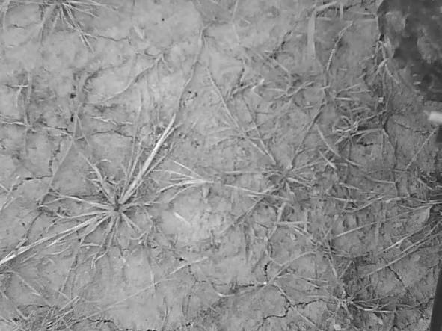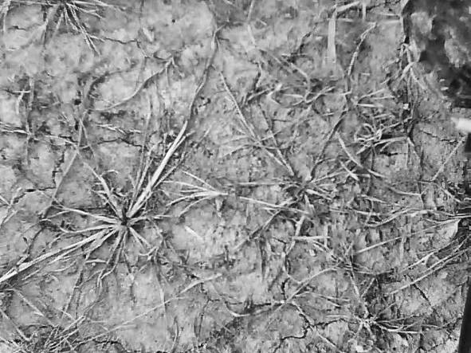
Fig. 1. Comparison of grayscale (left) and CLAHE (right).
1.6 kNN Matching
The k-Nearest Neighbors algorithm (kNN) is a method for pattern matching in non-parametric feature spaces, and is commonly used in computer-vision and machine learning. With respect to matching images, kNN is used to find the k-nearest neighbors of each keypoint within two images. To determine distance, a commonly used metric for continuous variables is the Euclidean distance, known as the L² norm. However, the feature vectors produced by binary descriptors, e.g. ORB, consist of discrete values and therefore the Euclidean distance overlap metric, also known as the Hamming norm, must be used. This provides a significant improvement in matching speed because calculating the Hamming norm only requires binary operations (e.g. XOR) which are very fast on modern microprocessors.
Implementations of the kNN algorithm in computer-vision commonly search for either one or two nearest neighbors, referred to as 1NN and 2NN, respectively. For example, 2NN produces two matches for each feature. Lowe et al. (2004) proposed a widely used method known as the ratio-test to filter for bad matches when using 2NN matching. For each feature in the first image, two matches are calculated in the second, the distance metric of each neighbor is compared, and the match is only accepted if the ratio between the two distances is less than some threshold, e.g. a threshold of 0.7 is typical. With respect to 1NN, calculating a single neighbor can result in poor performance as a match will be found for every single feature, even unmatchable ones. To address this, 1NN is often used with cross-checking. Cross-checking is based on the principle that the distance from one keypoint (A) to another keypoint (B) is not necessarily an invertible statement, i.e. B may be the closest point to A, but A may not be the closest point to B. Cross-checking computes 1NN for both directions, A-to-B and B-to-A, and a match is only accepted if A and B are closest for both directions (Figure 2).
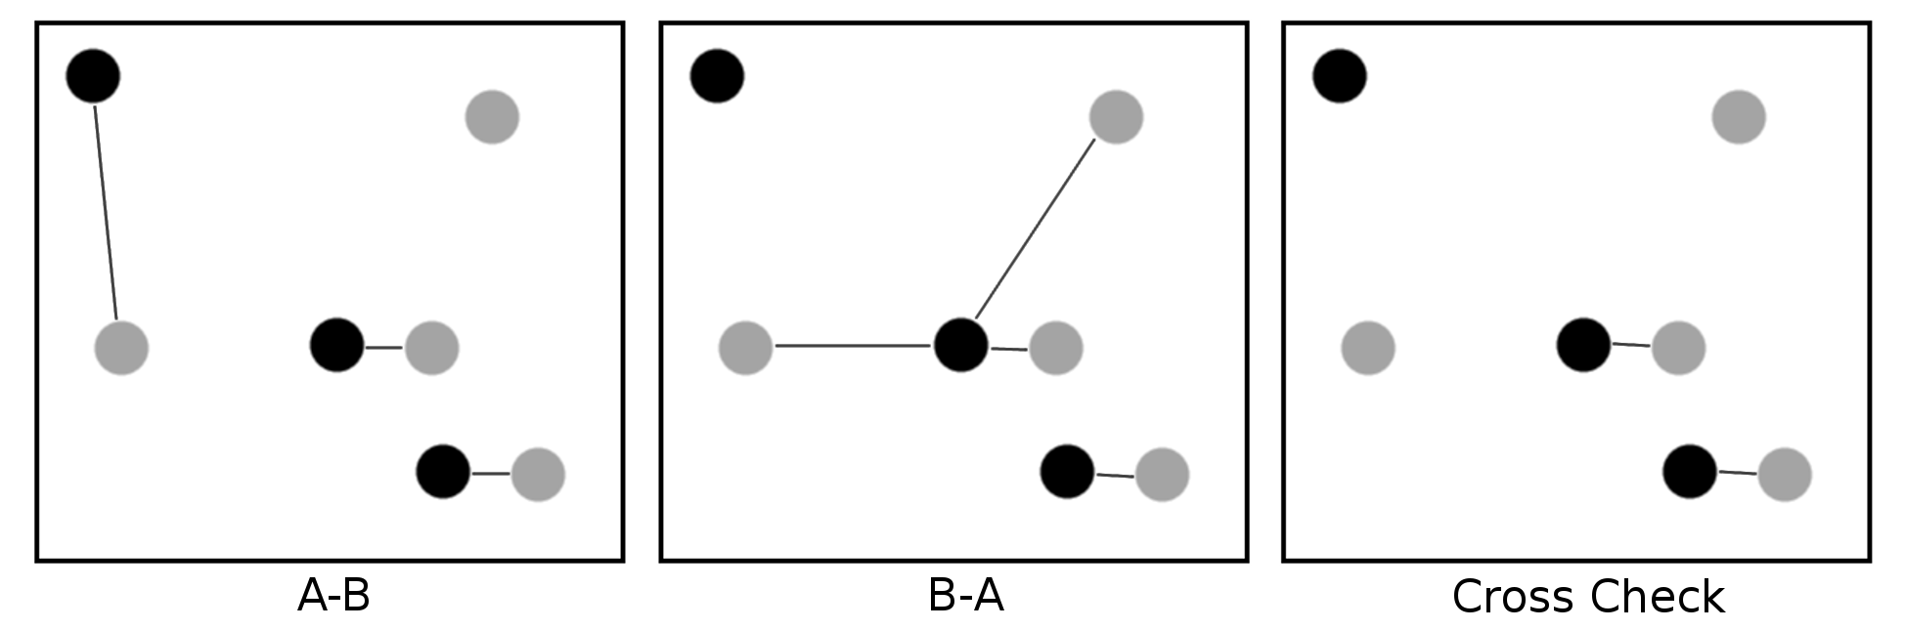
Fig. 2. 1NN matching (left) and 1NN matching with cross checking (right).
1.6 Objective
The goal of this study was to compare the efficiency of five feature-descriptor algorithms for monocular visual tracking: SURF, U-SURF, ORB, ORB with CLAHE pre-processing (CLORB), and SIFT. Motion vectors of an agricultural vehicle were determined for speeds from 1 m/s to 5 m/s on six surfaces to determine the reliability of each feature-descriptor with respect to computational efficiency, precision, robustness.
2. MATERIALS AND METHODS
A weatherproof camera with a resolution of 640 × 480 pixels was mounted to the front of a John Deere 850D Gator (John Deere, Illinois) at an orthogonal perspective relative to the ground surface and a height of 1.0 m (Figure 3). The camera had an aperture of 2.4 (F), a 6 mm focal point (f), and 1/3'' color CMOS sensor with an aspect ratio of 4:3 (Shenzhen Yufei Technology Co., Shenzhen, China). In order to maximize the overlap between consecutive images at higher travel speeds, the camera was oriented width-wise such that the 640 pixel axis of the camera sensor was aligned with the direction of travel. The camera was capable of automatic white-balance adjustment and had a frame capture rate of 25 Hz. The lens of the camera was not infrared (IR) filtered and the camera enclosure was equipped with 24 infrared LEDs. The camera was rated to a minimum illumination of 0.5 Lux and could be used effectively in a wide range of ambient lighting conditions.
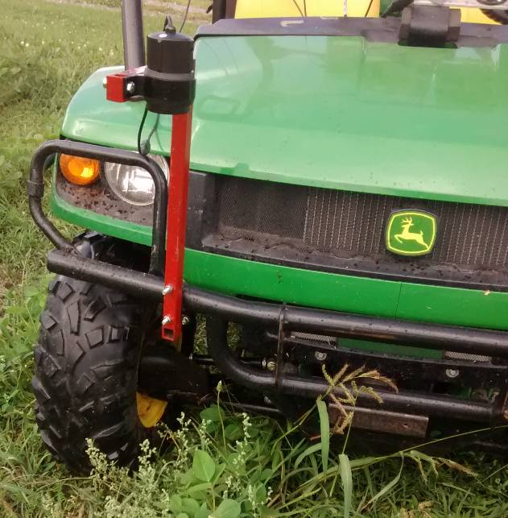
Fig. 4. Test vehicle and mounting bracket for camera.
After installation of the camera bracket, 10 calibration images were taken of a 9 × 7 checkerboard pattern in order to determine the camera distortion model (Lee, 2009). Corner detection was conducted on each image to find the geometric position of the 48 distinct corners. For each image, the corner points were used to fit a Brown-Conrady radial and tangential distortion model (Brown, 1966). The distance coefficients of each image were averaged to generate the distance coefficients used for radial and tangential distortion correction (1). Using the known dimensions of the squares (30 mm by 30 mm), an image resolution of 1.0 mm/px was achieved with this camera configuration.
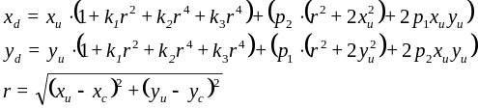 (1)
where radial terms k₁, k₂, and k₃ are -3.21×10¹, -6.03×10⁻³, and -3.22×10⁻³, respectively, and tangential terms p₁ and p₂ are -7.13×10⁻² and 2.41×10⁻⁷, respectively.
A Trimble AgGPS 542 RTK-GNSS rover and GA530 receiver (Trimble Navigation Ltd., Sunnyvale, California, USA) were mounted to the test vehicle. The RTK rover was configured to produce $GPVTG and $GPGGA NMEA strings at the maximum rate of 20 Hz. The base station was positioned in an open area and all trials were conducted within 2 km of the base station. An application was developed using the Python programming language (version 2.7.11) (Python Software Foundation, Wilmington, Delaware, USA) and OpenCV (version 2.4.9) (Itseez, Nizhny Novgorod, Russia) to capture videos with ultra low-latency and generate an accompanying RTK-GNSS datalog with high precision time-stamps (1 μs precision) corresponding to each image. The logging application was optimized to run on a 2.8 GHz Intel i7 VMC3501-K (Nexcomm, Taipei, Taiwan).
As specified by ISO 12188-2, the visual tracking system was evaluated from 1 m/s to 5 m/s (ISO, 2012) on six surfaces: asphalt, gravel, turf grass, seedlings, corn residue, and pasture (Figure 4). For each trial, the logging system and RTK-GNSS receiver were activated. Once an accurate satellite signal was acquired, the vehicle was engaged into gear and the accelerator was steadily applied until 5 m/s was reached. During each trial the operator attempted to maintain an average acceleration of 0.25 m/s² and a trial duration of approximately 45 seconds. For each surface type, five (5) replicates were conducted for a total dataset consisting of 32699 images. For each trial, the approximate height of the crop coverage relative to the ground surface was estimated.
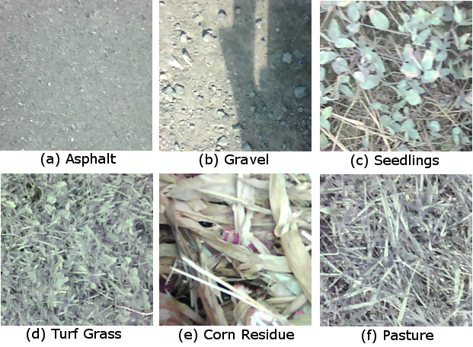
Fig. 4. Sample images of each of the six surfaces considered.
Five feature-descriptor algorithms were evaluated: SURF, U-SURF, ORB, ORB with CLAHE pre-processing (CLORB), and SIFT. Additionally, for each feature-descriptor algorithm, both 1NN with cross-checking and 2NN with the ratio-test (threshold of 0.7) were evaluated, for a total of 10 algorithm configurations. Post-processing of the collected video data was computed in a single thread on a Intel Xeon E31225 at 3.10 GHz to simulate performance similar to a high-end embedded system. Processing rates of each algorithm were calculated by comparing real-time clock readings to 1 μs precision at the beginning and end of each iteration
The visual tracking algorithm consisted of an iterative process with 9 sequential operations (Figure 5). First, the next RGB image was captured and converted to gray-scale. In the case of CLORB, an additional pre-processing step of CLAHE was performed on the gray-scale image. Next, lens distortion was corrected. Then, the feature-descriptor executed to detect keypoints in the image followed by kNN match keypoints of the current image to the keypoints of the previous image stored in memory. The set of matches produced was then converted to polar vectors and a histogram vector filter was applied to eliminate "bad" vectors. Lastly, the dominant vector direction and displacement were calculated using the set of all "good" vectors.
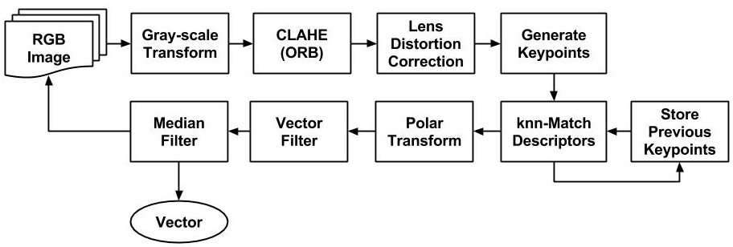
Fig. 5. Process diagram of visual tracking algorithm.
With respect to SURF and U-SURF, common parameters discussed in the literature and by Bay et al. (2008) were used, specifically: four (4) Gaussian pyramid octaves and two (2) images within each octave of a Gaussian pyramid. Also based on the literature, kNN matching of SURF floating-point descriptors was conducted using the L² norm distance metric. With respect to SIFT, algorithm parameters similar to that used in Lowe et al. (2008) were used: the number of octave layers was set to three (3), and the contrast and edge thresholds were set to 0.04 and 10, respectively. As per the literature, kNN matching of SIFT floating-point descriptors was conducted using the L² norm distance metric. With respect to ORB, two variants were evaluated: ORB and ORB with CLAHE pre-processing (CLORB). Both algorithms were configured to use an edge threshold of 31, a patch size of 31, eight (8) pyramid levels, and two (2) randomized pairs for BRIEF intensity comparisons. As per the literature, kNN matching of ORB binary descriptors was conducted using the Hamming norm distance metric. In the case of CLORB, CLAHE with a clip limit of 2 and a tile grid size of 8 × 8 was used.
kNN matching with the ratio test or cross-checking are still prone to highly non-parametric errors in visual tracking and it is necessary to filter the set of all possible vectors to remove any outliers. With respect to visual tracking of orthogonal images, the set of motion vectors was assumed to be unimodal. A computationally inexpensive histogram filter was employed (2). First, a 360 bin histogram (H) of the integer-rounded θ-values was generated. Next, the discrete 2nd-order gradient (3) of the histogram's cumulative summation (4) was used to calculate an array of differences (D). The centroid vector angle corresponding to the maximum value of the gradient array was found (θ_{C}) using the argmax function (5). The best estimate for the motion vector (v_{m}) between two consecutive frames was assumed to be the median and mean of the sets of all vector radii (R_{k}) and all vector angles (ϴ_{k}), respectively, for all vectors within a tolerance of 1˚ of θ_{C}:
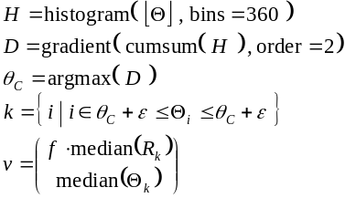 (2)
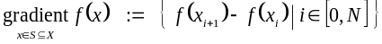 (3)
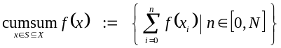 (4)
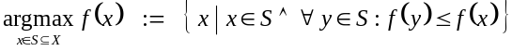 (5)
This methodology proved to be an effective for determining the dominant motion vector, even in the case of persistent shadows or non-moving objects (e.g. vehicle frame) in the field of view. This filter only required 2 ms per 640 × 480 image compared to 7 ms for RANSAC. Figure 6 shows an example of the histogram filter rejecting "bad" vectors.
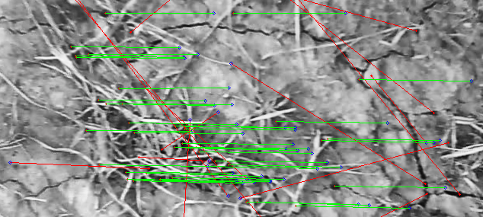
Fig. 6. Visual tracking with "bad" vector filtering.
For subsequent analysis of the data, tracking values of the RTK-GNSS were smoothed using a 5-point 1st-order Savitsky-Golay filter to reduce vibration effects. Similarly, vector estimates from feature-based visual tracking were smoothed using a 5-point moving median filter instead of Savitsky-Golay filtering due to the non-parametric nature of error distribution. In order to determine the efficiency of visual tracking irrespective of vehicle dynamics a Kalman filter was not implemented.
3. RESULTS
Figure 7 presents a comparison between two trials demonstrating the extremes of performance. Generally speaking, the visual tracking methods demonstrated similar accuracy compared to RTK-GNSS. All of the feature-descriptors exhibited better performance on surfaces which were more homogeneous (e.g. asphalt, gravel) compared to heterogeneous surfaces (e.g. corn residue).
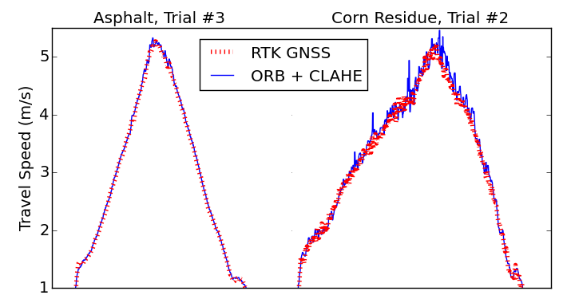
Fig. 7. Examples of trials which produced good (left) and bad (right) visual tracking.
Table 1 shows a summary of 95th percentile errors and average processing times for each combination of feature-descriptor algorithm and matching method. It can be seen that including CLAHE as a pre-processing step for ORB reduced the error compared to standard ORB. SIFT performed best overall, but also exhibited the slowest computational speed.
Table 1. Summary of algorithms
 |  | 95th Percentile (m/s)
 | Hz | Total | 1 - 2 m/s | 2 - 3 m/s | 3 - 4 m/s | 4 - 5 m/s
SURF₂₀₀₀  (1NN) | 8.7 | 0.29 | 0.17 | 0.22 | 0.30 | 0.35
SURF₂₀₀₀  2NN) | 8.7 | 0.25 | 0.14 | 0.18 | 0.30 | 0.30
U-SURF₂₀₀₀ (1NN) | 15.1 | 0.24 | 0.16 | 0.17 | 0.25 | 0.29
U-SURF₂₀₀₀ (2NN) | 10.9 | 0.22 | 0.14 | 0.17 | 0.25 | 0.27
ORB₅₀₀  (1NN) | 34.2 | 0.25 | 0.13 | 0.16 | 0.40 | 0.32
ORB₅₀₀  (2NN) | 37.6 | 0.23 | 0.13 | 0.21 | 0.31 | 0.27
CLORB₅₀₀ (1NN) | 24.0 | 0.24 | 0.13 | 0.17 | 0.32 | 0.30
CLORB₅₀₀ (2NN) | 25.3 | 0.23 | 0.13 | 0.18 | 0.27 | 0.27
SIFT₅₀₀  (1NN) | 5.5 | 0.21 | 0.13 | 0.15 | 0.22 | 0.29
SIFT₅₀₀  (2NN) | 5.4 | 0.21 | 0.13 | 0.16 | 0.23 | 0.26
Figure 8 presents the normalized frequency distribution of errors for visual tracking relative to RTK-GNSS data. Two curves are presented: 1) uncompensated ground speed, and 2) ground speeds which were corrected using a constant conversion factor based on surface height (Equation 7). As can be seen, the gravel, asphalt, and seedling surfaces showed negligible difference between the uncompensated and compensated methods.
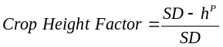 (7)
where P is the zoom power (1.0918), SD is the ideal subject depth (100 cm), and h is the crop height (in cm).
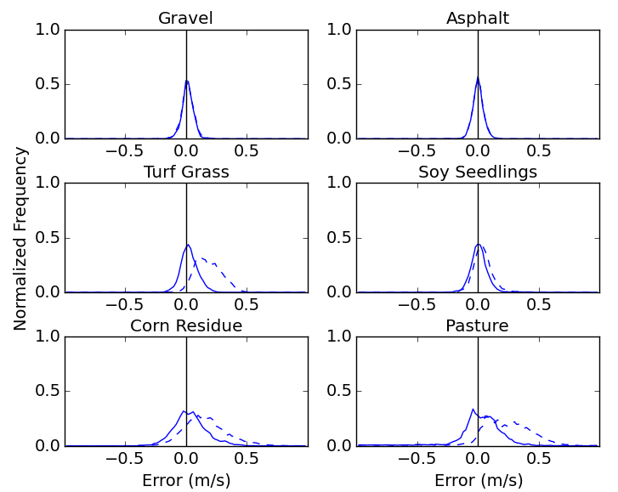
Fig. 8. Normalized frequency of errors for uncompensated (solid) and depth compensated (dashed).
Figure 9 presents the Tukey HSD multiple comparison plot for each feature-descriptor with respect to surface. Pasture and asphalt presented a noticeable shift for SURF, U-SURF and ORB for both kNN methods. Similarly, CLORB and SIFT had significantly lower variances compare to the other three feature-descriptors.
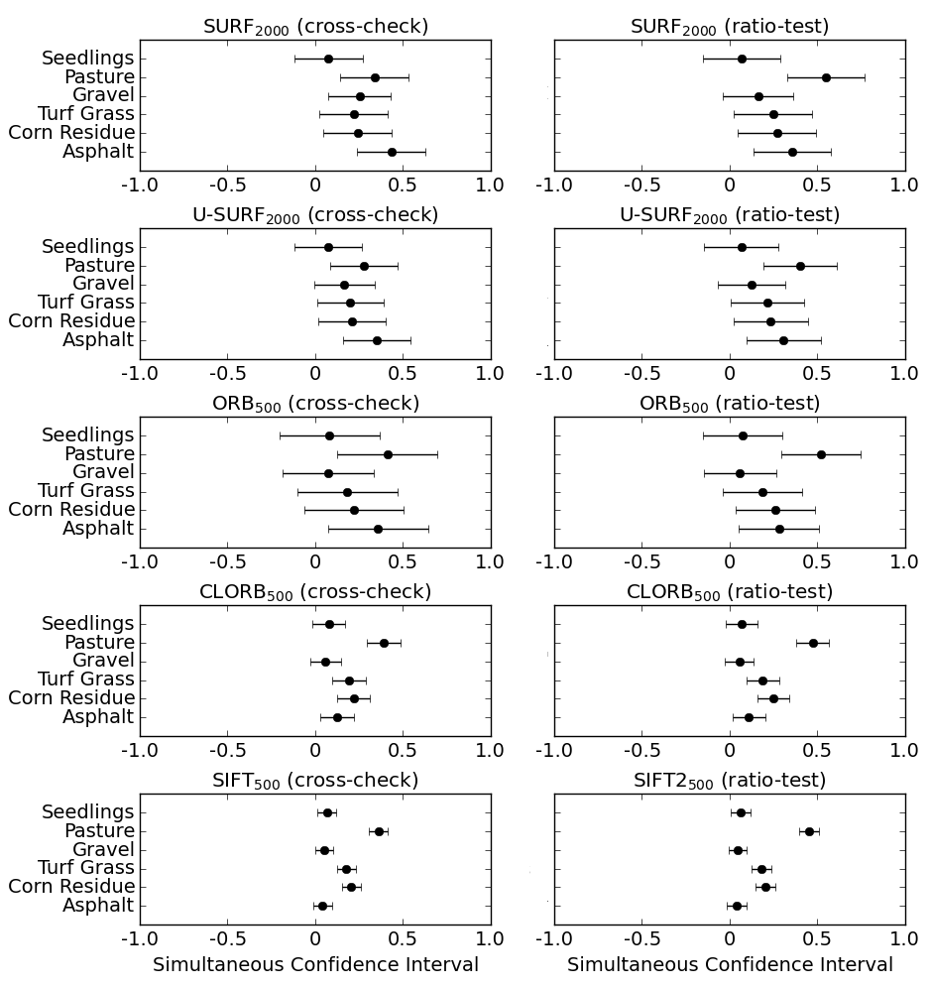
Fig. 9. Tukey HSD multiple comparison of RMSE values by with respect to feature-descriptor-matcher and surface.
4. DISCUSSION
Although the ORB algorithm was computationally efficient, it demonstrated reduced accuracy for speeds from 3 to 5 m/s compared to SIFT, SURF and CLORB (Table 1). U-SURF not only outperformed SURF, but was computationally faster by 50% (Table 1). Variants of the SIFT algorithm exhibited the best overall precision and this difference was most noticeable on asphalt (Figure 9). Incorporating CLAHE processing prior to the ORB algorithm greatly improved reliability, and despite the increased computational cost, was capable of real-time performance of greater than 25 Hz (Table 1). Overall, there was a general relationship between precision and complexity of feature-description. For example, SIFT exhibited best precision, but also significantly slower computational time (Table 1). All of the algorithms exhibited very close correlation to RTK-GNSS values with the exception of ORB.
These results suggest that agricultural applications which require real-time vector estimation might consider ORB with CLAHE due to the beneficial compromise between precision and computational speed. However, applications which require high accuracy vector estimations and do not have strict time constraints should continue to use U-SURF due to its excellent performance on all surfaces and at all travel speeds. For tractor performance testing on concrete and asphalt, both of which are very homogeneous surfaces for visual tracking, SIFT had the best performance due to DoG's ability to find distinctive keypoints regardless of noise and image homogeneity.
4.1 Future Research
Monocular visual tracking may be a viable component of sensor fusion systems, specifically for depth estimation. Current methodologies for crop height detection utilize ultrasonic (Gil, 2007), LIDAR (Llorens, 2011), or stereovision systems (Kise, 2005). For modern tractors with CANBUS connectivity, the ratio between implemented-mounted visual tracking systems and RTK-GNSS tracking data may be sufficient for estimating of crop canopy without the need for ultrasonic or laser distance sensors. Such a system may be easily integrated with existing monocular vision systems being used for sectional sprayer control.
Visual tracking may also prove to be valuable for guidance systems. For example, the pivoting action of some cultivator hitch steering systems will effectively change the lateral offset of implement-mounted cameras relative to the crop row. Therefore, visual tracking may prove to useful for orientation compensation of such systems (Appendix A).
5. CONCLUSION
Real-time visual tracking for agricultural implements has great potential for feedback and control applications. When comparing visual tracking against RTK-GNSS, ORB with CLAHE pre-processing (CLORB) and 1NN cross-checking was the most robust with respect to real-time applications. CLORB achieved 95th percentile error of 0.23 m/s and faster processing times than RTK-GNSS. These results suggest that agricultural applications which require real-time vector estimation with low-cost cameras might consider CLORB due to the algorithm's beneficial compromise between precision, reliability, and computational speed.
REFERENCES
Bay, H., Ess, A., Tuytelaars, T., & Van Gool, L. (2008). Speeded-up robust features (SURF). Computer vision and image understanding, 110(3), 346-359.
Brown, D.C. (1966). Decentering distortion of lenses. Photogrammetric Engineering, 32 (3), 444–462.
Griepentrog, H.W., Skou, P.T., Soriano, J.F., & Blackmore, B.S. (2005). Design of a seeder to achieve highly uniform sowing patterns. Proc. 5th European Conf. on Precision Agriculture, 675-682.
Hague, T., Tillett, N.D., & Wheeler, H. (2006). Automated crop and weed monitoring in widely spaced cereals. Precision Agriculture, 7(1), 21-32.
El Harraj, A., & Raissouni, N. (2015, January). Histo-binary combined corner enhancement (HBCCE) improved algorithm for image processing corner detection. Proc. of the International Conference on Image Processing, Computer Vision, and Pattern Recognition (IPCV), 95-101.
Gan-Mor, S., Clark, R.L., & Upchurch, B.L. (2007). Implement lateral position accuracy under RTK-GPS tractor guidance. Computers and Electronics in Agriculture, 59(1), 31-38.
Gauglitz, S., Hèollerer, T., & Turk, M. (2011). Evaluation of Interest Point Detectors and Feature Descriptors for Visual Tracking. International Journal of Computer Vision, 94( 3), 335-360.
Gil, E., Escolà, A., Rosell, J.R., Planas, S., & Val, L. (2007). Variable rate application of plant protection products in vineyard using ultrasonic sensors. Crop Protection, 26(8), 1287-1297.
ISO. (2012). ISO 12188-2: Tractors and machinery for agriculture and forestry -- Test procedures for positioning and guidance systems in agriculture -- Part 2: Testing of satellite-based auto-guidance systems during straight and level travel. Geneva, Switzerland: ISO.
Kise, M., Zhang, Q., & Más, F. R. (2005). A stereovision-based crop row detection method for tractor-automated guidance. Biosystems Engineering, 90(4), 357-367.
Lowe, D. (2004). Distinctive image features from local scale-invariant keypoints. International Journal of Computer Vision, 60(2), 91-110.
Lee, S. H., Lee, S. K., & Choi, J. S. (2009). Correction of radial distortion using a planar checkerboard pattern and its image. IEEE Transactions on Consumer Electronics, 55(1), 27-33.
Nistér, D., Naroditsky, O., & Bergen, J. (2006). Visual odometry for ground vehicle applications. Journal of Field Robotics, 23(1), 3-20.
Pizer, S. M., Johnston, R. E., Ericksen, J. P., Yankaskas, B. C., & Muller, K. E. (1990). Contrast-limited adaptive histogram equalization: speed and effectiveness. Proc. of the First Conf. on Visualization in Biomedical Computing, 337-345.
Rosten, E., Porter, R., & Drummond, T. (2010). Faster and better: A machine learning approach to corner detection. Pattern Analysis and Machine Intelligence, IEEE Transactions on, 32(1), 105-119.
Rublee, E., Rabaud, V., Konolige, K., & Bradski, G. (2011). ORB: an efficient alternative to SIFT or SURF. IEEE International Conf. on Computer Vision, 2564-2571.
Scaramuzza, D. & Siefwart, R. (2008). Appearance-Guided Monocular Omni-directional Visual Odometry for Outdoor Ground Vehicles. IEEE Transactions on Robotics, 24(5), 1015-1026.
Thansandote, A., Stuchly, S.S., Mladek, J., Townsend, J.S., & Shlosser, H. (1977). A new slip monitor for traction equipment. Transactions of the ASAE, 20(5), 851-856.
Tompkins, F.D., Hart, W.E., Freeland, R. S., Wilkerson, J.B., & Wilhelm, L.R. (1988). Comparison of tractor ground speed measurement techniques. Transactions of the ASAE, 31(2), 369-374.
Yadav, G., Maheshwari, S., & Agarwal, A. (2014). Contrast limited adaptive histogram equalization based enhancement for real time video system. Communications and Informatics International Conference on Advances in Computing, 2392-2397.
Zuiderveld, K. (1994). Contrast limited adaptive histogram equalization. Graphics gems IV, 474-485. Academic Press Professional, Inc..
Appendix A. ORIENTATION COMPENSATION
Computer-vision systems have been successfully employed on cultivators for row detection (Hague, 2006). However, pivoting-hitch systems, such as the Sunco AcuraTrak (Sunco Manufacturing, North Platte, Nebraska, USA), pose a particular set of challenges for row estimation. The action of the hitch effectively changes the orientation of implement mounted cameras relative to the crop row. Therefore, the system will over- or under-estimate lateral error depending on configuration and tracking direction.
Guidance errors caused by the motion of a pivoting-hitch can be mitigated by employing rotation compensation based on vector information with visual tracking. Assuming that the longitudinal component of the implement's velocity in the direction of the crop row (V_{y}) is much greater than the rate of lateral adjustment (V_{x}), the small angle approximation applies and the orientation of the image can be corrected by applying a rotational matrix transform about the pivot point.
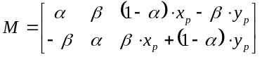 (8)
where α = cos(θ), β = sin(θ), and (x_{p}, y_{p}) is the pivot-point about which the image will be rotated (mm).
However, for hitches with low pivot range or embedded systems with limited processing power, this transform may not be practical to compute. For example, if the rotational range of the hitch is less than ±5°, e.g. the AcuraTrak has a range of ±5°, the positional error of the image centroid relative to the crop row may be approximated by the following equation:
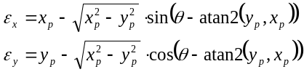 (9)
where x_{p} is the lateral distance from camera to the pivot point, y_{p} is the longitudinal distance from camera to the pivot point, and θ is the instantaneous orientation of the camera relative to the direction of travel.

